**Welcome to the Waterwatch Data Portal: A Quick reference guide**

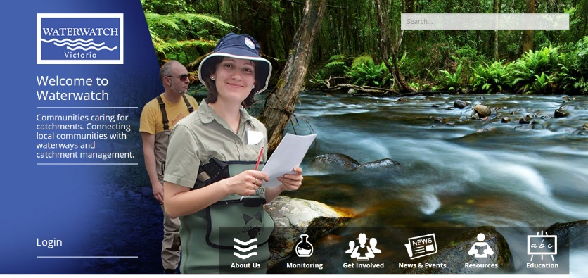Getting started

Access the site at:

http://www.vic.waterwatch.org.au/

Login the portal by clicking ‘Login’ on

the left side of the home page screen.

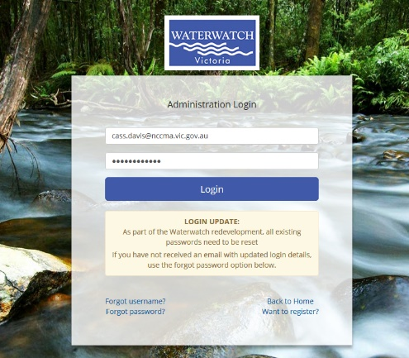Login to the portal

Enter your username and password

Username:

Password:

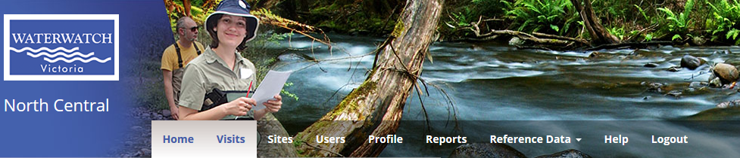Check and update your details

In the portal, click the **‘Profile’** tab.

Check your details are all up to date.

If you’re details need updating:

Type in the new information or change

any out of date information.

Click **‘Update details’** button at the

bottom of your screen when finished

to save the changes.

Note: those with a * are mandatory

fields.

**How to enter data**

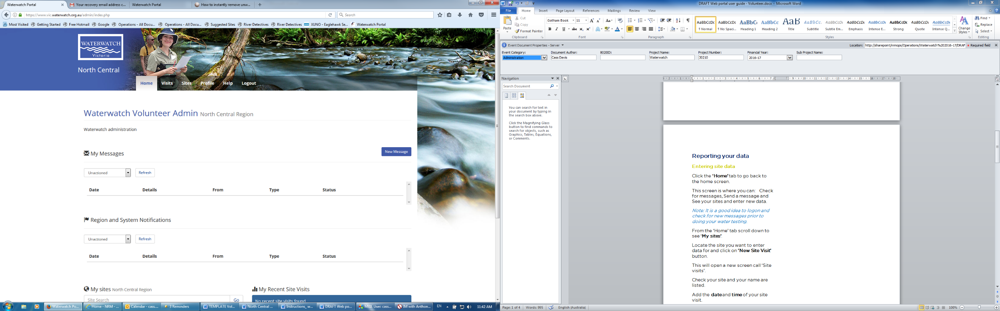Entering site data

Click the **‘Home’** tab to go to

the home screen.

This screen is where you can:

• Check for messages,

• Send a message

• See your sites and enter new data.

Note: It is a good idea to logon and

check for new messages prior to

doing your water testing.

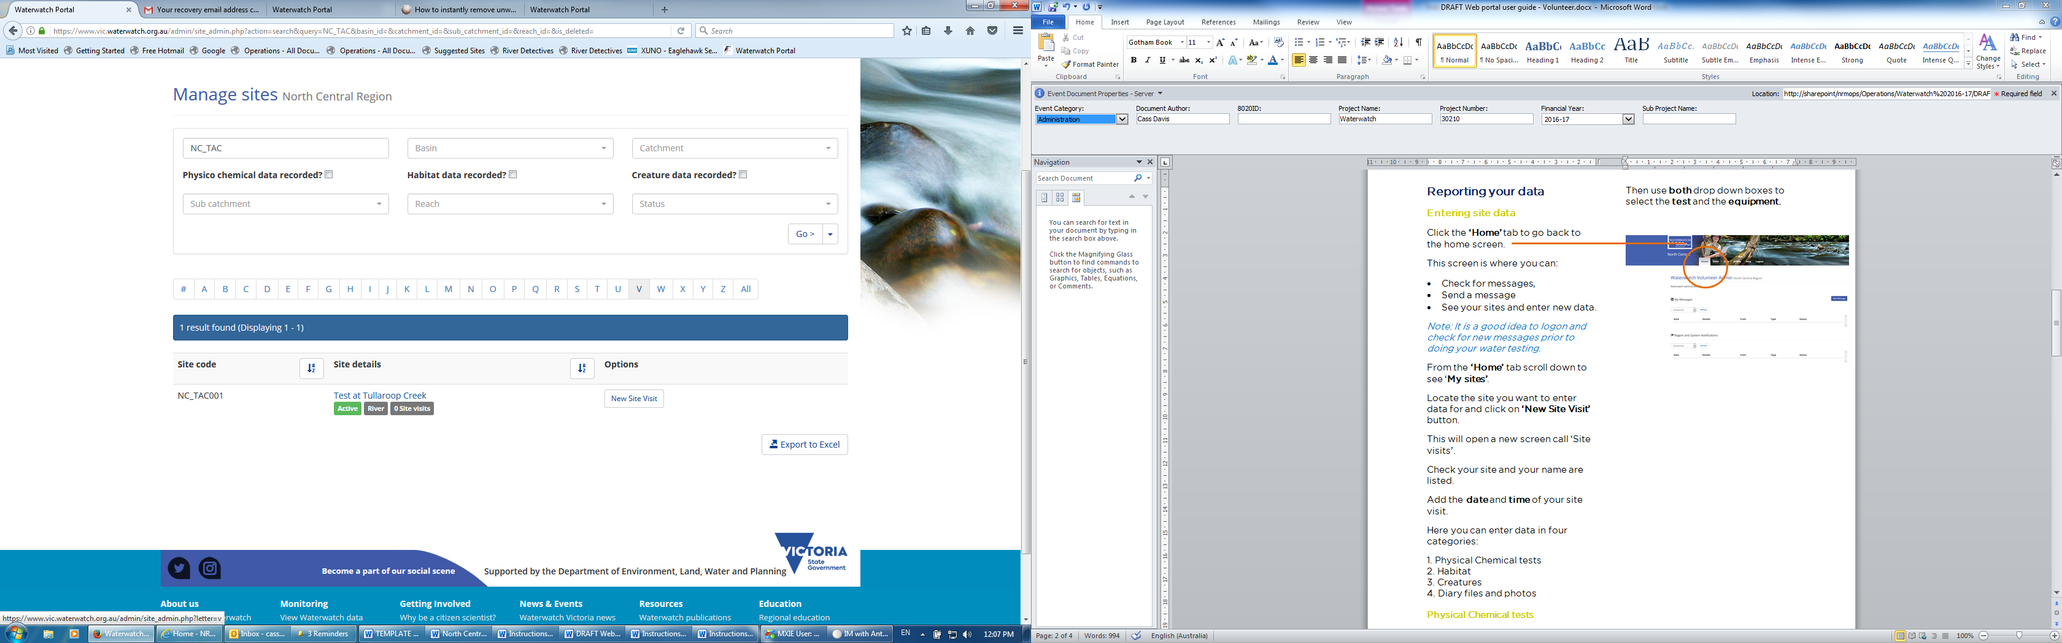From the **‘Home’** tab scroll down to

see **‘My sites’**.

Locate the site you want to enter

data for and click on **‘New Site Visit’**

button.

Enter Date and Time

Add the date and time of your site visit

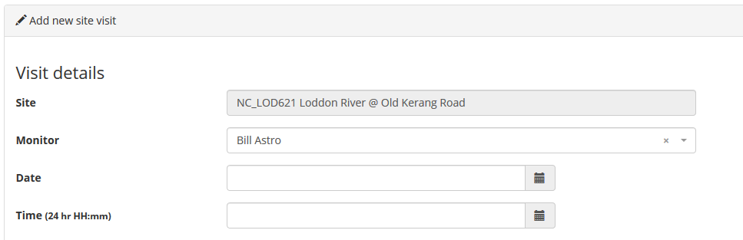

Entering your data

To add your data simply type your results into the results column

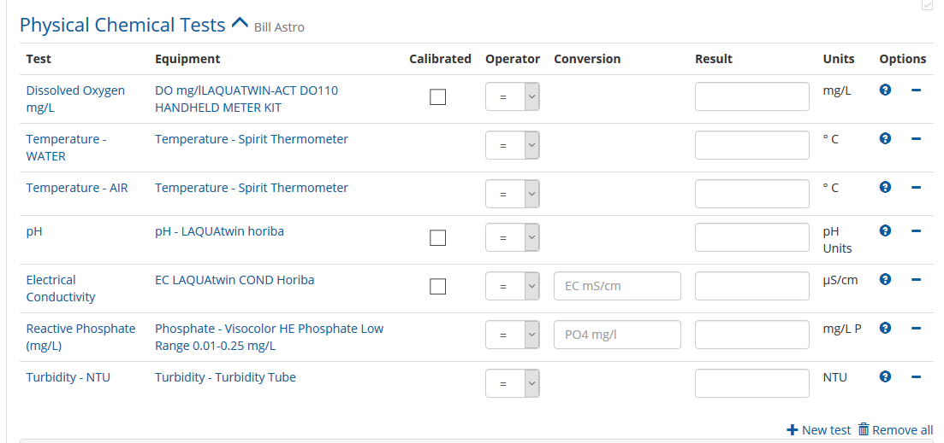

Please note: If a test has not been completed you will need to remove it from the list, you can do this by clicking the blue dash/minus sign, under **‘Options’** next to your test.

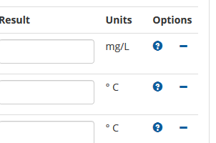

Entering observations

Add any observations you observe when you are at your site, you can enter this data here:

Please note: this is not compulsory, you do not need to capture this information, but it can help us tell a story about your site.

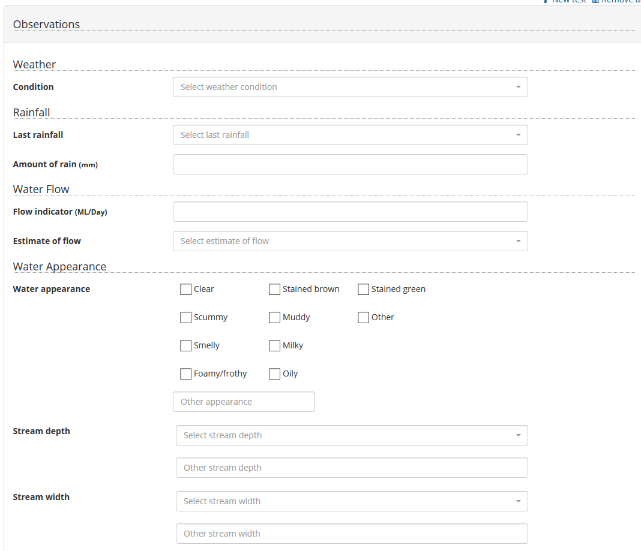

Add any comments:

You can add any comments here about your site or other info about flora and fauna, this is like a diary for you.

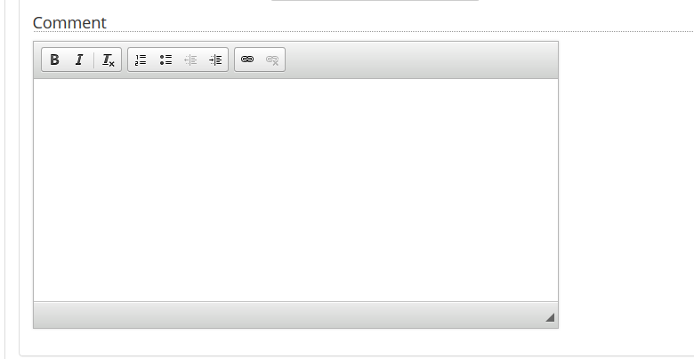

When you have completed your tests click on ‘Continue’ at the bottom of the page, or if you want to add other information stay on this page and add the data. (see below for more options)

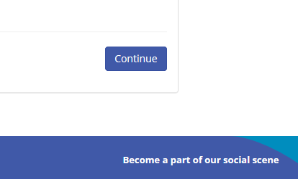

Entering a photo

At the bottom of the page, click Diary Filed and photos

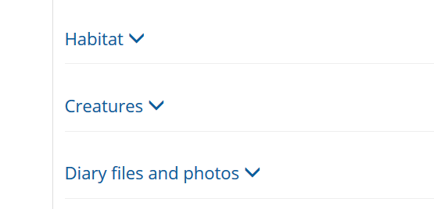

Then click on **‘add files’**

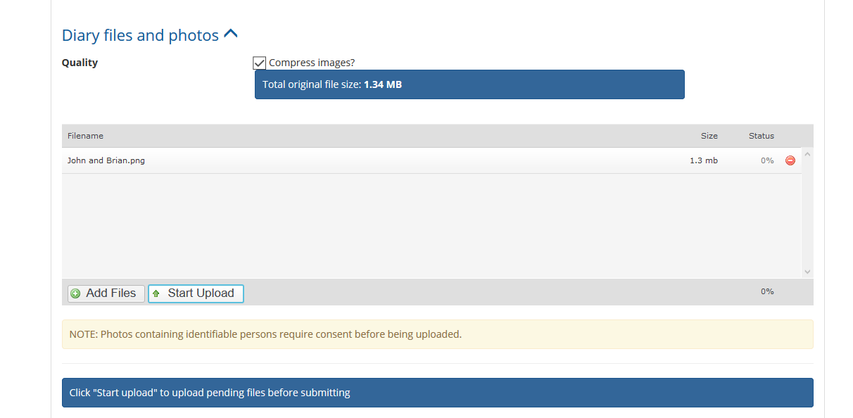

Select image from your desktop and click **‘open’**

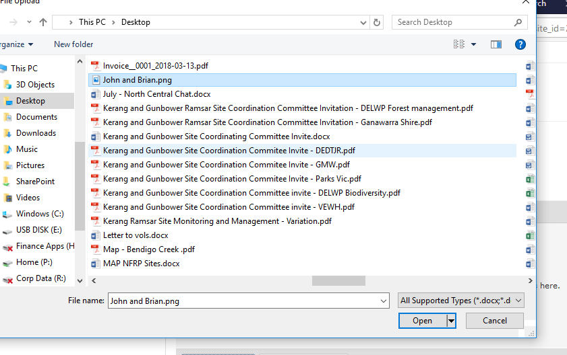

Enter relevant information about the photo in the fields

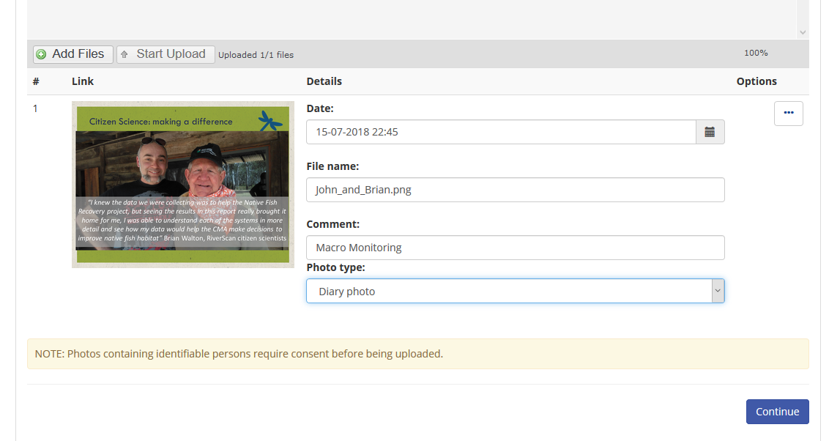

When you have completed your tests click on ‘Continue’ at the bottom of the page, or if you want to add other information stay on this page and add the data. (see below for more options)

