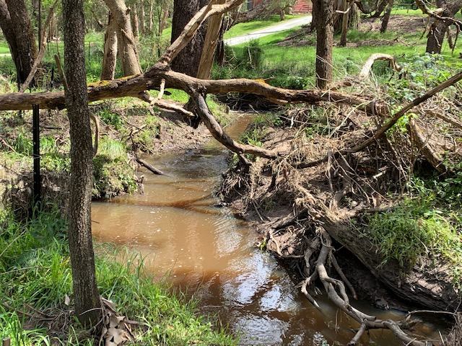
Potential new site for MI surveys in Splitters Creek about 20 m north of confluence with Main Creek

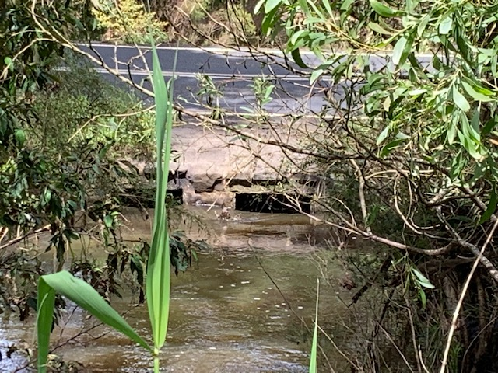

Main Creek flowing under Baldrys Road, usually ~ 1 metre below the concrete

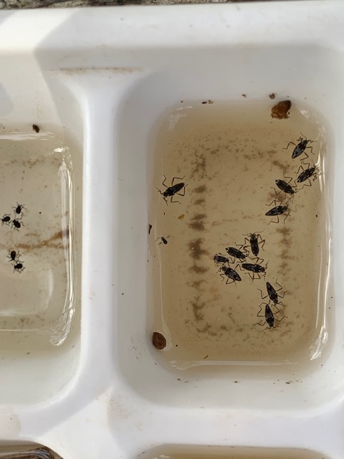 Water treaders - Veliidae

