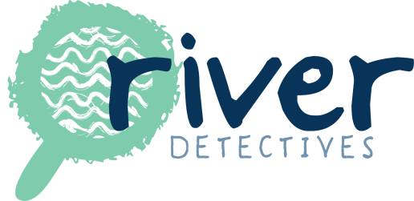

Application Form - River Detectives program 2017

Please complete the following form by Friday 16 December.

School name

Contact teacher

Teacher’s email

Second contact teacher* *Required please

Teacher’s email

School email

School address

Phone

Number of students # | {# in your school}
Who will participate in the program?^ | {^Please indicate the proposed year level/s/ class/es /focus groups etc. who would monitor their local waterway and how often – i.e. for one term, monthly etc}
Proposed Waterway our school would monitor* | {*If you are unsure please note this and we can work together to choose one.}
Please tell us why your school is enthusiastic to monitor your local waterway in 2017 | {E.g. Is your school involved in other environmental programs? e.g. AuSSI Vic, Waterwatch – please let us know! Does your school have links to other environment groups or agencies? We might be able to link in, so let us know!}

Professional development session

Please contact us to find out more about professional development dates and sessions in your region.

Thank you! We will let you know by before Term 1, 2017 if your school has been successful in its application to be part of the River Detectives program for 2017.

